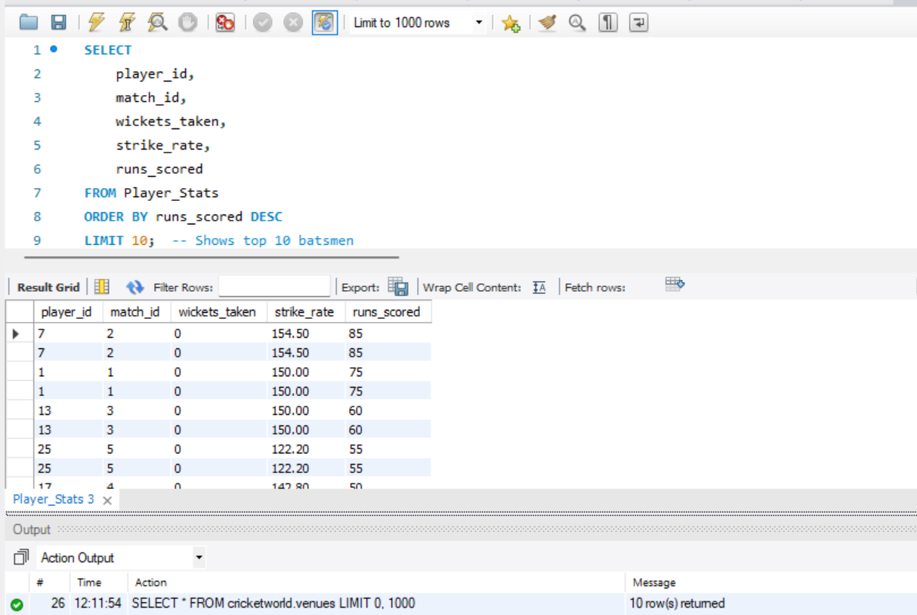

**#Player Performance Summary**

* Top batsmen (highest runs), top bowlers (most wickets), and best strike rate.

SELECT

player_id,

match_id,

wickets_taken,

strike_rate,

runs_scored

FROM Player_Stats

ORDER BY runs_scored DESC

LIMIT 10;